# 4. DESIGN AND TRAIN A MODEL FOR OBJECTS DETECTION WITH REAL TIME EXAMPLE

|  |  |
| --- | --- |
| **EX.N0 : 4** | **DESIGN AND TRAIN A MODEL FOR OBJECTS DETECTION WITH REAL TIME EXAMPLE** |
| **DATE : 11/02/2025** |

**AIM:**

To design and train a real-time object detection model using YOLO to detect objects such as cars, people, or other items in video or camera feed.

# ALGORITHM:

Step 1: Import necessary libraries (TensorFlow, OpenCV, NumPy). Step 2: Load a pre-trained YOLO model (YOLOv3, for example).

Step 3: Load and pre-process the input video or camera feed.

Step 4: Visualize detected objects with bounding boxes and class labels. Step 5: Output the video with real-time object detection.

# PROGRAM:

import cv2

import numpy as np

yolo_model = "yolov3.weights" # Path to YOLOv3 weights yolo_cfg = "yolov3.cfg" # Path to YOLOv3 configuration

yolo_names = "coco.names" # File with class names (e.g., coco dataset) net = cv2.dnn.readNet(yolo_model, yolo_cfg)

layer_names = net.getLayerNames()

output_layers = [layer_names[i - 1] for i in net.getUnconnectedOutLayers()] with open(yolo_names, 'r') as f:

classes = [line.strip() for line in f.readlines()]

cap = cv2.VideoCapture(0) # 0 for webcam, or video file path for custom video while True:

ret, frame = cap.read() if not ret:

break

blob = cv2.dnn.blobFromImage(frame, 0.00392, (416, 416), (0, 0, 0), True, crop=False) net.setInput(blob)

outs = net.forward(output_layers) class_ids, confidences, boxes = [], [], [] height, width, channels = frame.shape for out in outs:

for detection in out:

scores = detection[5:] class_id = np.argmax(scores) confidence = scores[class_id]

if confidence > 0.5: # Set confidence threshold (e.g., 50%) center_x = int(detection[0] * width)

center_y = int(detection[1] * height) w = int(detection[2] * width)

h = int(detection[3] * height) x = center_x - w // 2

y = center_y - h // 2 boxes.append([x, y, w, h])

confidences.append(float(confidence)) class_ids.append(class_id)

indexes = cv2.dnn.NMSBoxes(boxes, confidences, score_threshold=0.5, nms_threshold=0.4) for i in range(len(boxes)):

if i in indexes:

x, y, w, h = boxes[i]

label = str(classes[class_ids[i]]) confidence = str(round(confidences[i], 2))

color = (0, 255, 0) # Green color for boxes cv2.rectangle(frame, (x, y), (x + w, y + h), color, 2)

cv2.putText(frame, label + " " + confidence, (x, y - 10), cv2.FONT_HERSHEY_SIMPLEX, 0.5, color, 2)

cv2.imshow('Object Detection', frame) if cv2.waitKey(1) & 0xFF == ord('q'): break

cap.release() cv2.destroyAllWindows() **OUTPUT:**

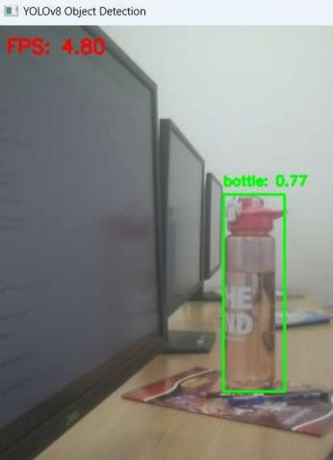

# RESULT:

Thus the Program has been executed successfully and verified.